CD22-targeted CAR T cells Induce Remission in B-ALL Resistant to CD19-targeted CAR Immunotherapy

Student’s Name
Institutional Affiliation
Course Name and Number
Instructor’s Name
Assignment Due Date

Rates at which children with B-ALL are cured have risen up to 90% as compared to those with relapsed chemotherapy-refractory disease. Also, adults with B-ALL exhibit a less than 50% survival rates even when treated with pediatric therapy. Immunotherapies which target CD19 have provided new antibodies that suppress and in isolated cases treat B-ALL.
This study aims to establish the facts around the investigation that CD22-targeted CAR T cells induce remission in B-ALL that is resistant to CD19-targeted CAR immunotherapy. Samples of adults and children were taken to ascertain this claim. Research reveals that CD22-targeted CAR T cells induce remission in B-ALL that is resistant to CD19-targeted CAR immunotherapy

Dose level 1
Dose level 2
Dose level 3
100 50 0 -50 -100
Absolute change in bone marrow blasts
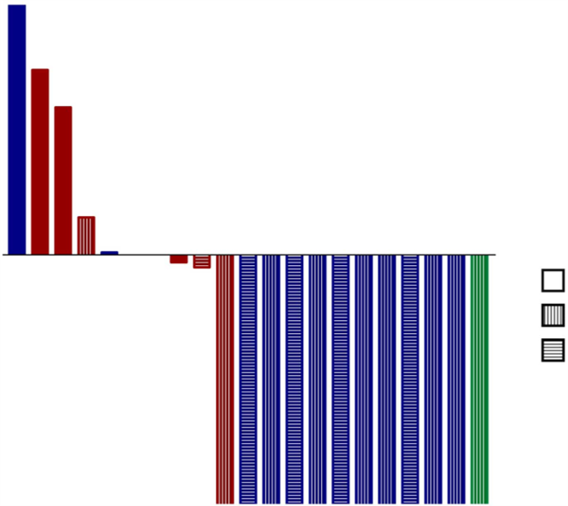
18 5 6 3 12 17 10 1 4 2 7 8 9 13 14 15 16 19 20 21 11 Patient No
Chimeric antigen receptor (CAR) T cells targeting CD19 have also shown good antileukemic results in children and adults with refractory B-ALL, with the statistics on remission going from 70-90%. Although these are impressive results, the likelihood of a long-lasting remission is still unknown. The chances of relapses with diminished cell-surface expression of CD19 are alarmingly identified as a cause of treatment failure.
10,000 –

1000 –

100 –

10 –

1-
CD22 site density (sites, cell)

Patient 15
Pre-treatment Relapse

Despite the major strides made, the toxicity experienced by patients, majorly cytokine release syndrome (CRS) has occurred in 16 of 21 patients. This coincided with the expansion of CAR T cell and began 5 days after treatment in all the affected patients. Protocol-defined (Online Methods) grade 1 CRS occurred in nine patients, and grade 2 CRS occurred in seven patients. This is a major setback that can’t be ruled out just like that.
The author doesn’t provide enough evidence to rule out the aspects of toxicity and its viability in adults with underlying conditions. With little to no evidence refuting these claims, doubt continues to grow in terms of treatment reliability and viability.
In summary, although there is sequential immunotherapeutic targeting of another antigen showing clinical benefit, there is a high rate of relapse in patients, cutting across the board from children to adults, arguing that simultaneous multispecific targeting may be a more susceptible approach to strengthen the longevity of immunotherapy-induced remission in B-ALL. A CAR that simultaneously combats both CD-19 and CD-22 would prove more effective at bringing about remission in patients while lowering the risk of relapse.
In conclusion, this study confirms that CD22-targeted CAR T cells induce remission in B-ALL that is resistant to CD19-targeted CAR immunotherapy.

Reference
Fry, T. J., M.D. (2018). CD22-targeted CAR T cells induce remission in B-ALL that is naive or resistant to CD19-targeted CAR immunotherapy.

